# Skin Cancer classification using Deep Learning CNN Models

**A PROJECT REPORT**

*for*

**Artificial Intelligence**

*in*

**B.Tech (IT)** *by*

**Kavali Venkata Sai Sankar Kumar (19BIT0030)**

**Amartya Sharma (19BIT0021)**

**Winter Semester, 2021**

*Under the Guidance of*

**Dr. R.Subhashini**

SITE



**School of Information Technology and Engineering**

NOV, 2021

# DECLARATION BY THE CANDIDATE

We here by declare that the project report entitled **“TITLE”** submitted by us to Vellore Institute of Technology University, Vellore in partial fulfillment of the requirement for the award of the course **Artificial Intelligence (ITE2010)** is a record of bonafide project work carried out by us under the guidance of DR**. R SUBHASHINI.** We further declare that the work reported in this project has not been submitted and will not be submitted, either in part or in full, for the award of any other course.

Place : Vellore Signature

Date : 29-Nov-2021



**School of Information Technology & Engineering [SITE]**

# CERTIFICATE

This is to certify that the project report entitled **“TITLE”** submitted by**Kavali Venkata Sai Sankar Kumar(19BIT0030),Amartya Sharma(19BIT0021)** to Vellore Institute of Technology University, Vellore in partial fulfillment of the requirement for the award of the course **Artificial Intelligence (ITE2010)** is a record of bonafide work carried out by them under my guidance.

**DR.R SUBHASHINI**

**GUIDE**

**SITE**

# Skin Cancer classification using Deep Learning

Classification of Skin cancer Using TensorFlow backend and pre-trained CNN algorithms in a organized pipeline fashion

**Kvs. Sankar Kumar, Amartya Sharma**

**1,2  Department of Information Technology, VIT University, Vellore, Tamil Nadu, India**

|  |  |
| --- | --- |
| Name | Individual Contribution |
| Kvs. Sankar Kumar | 5 literature surveys, Introduction, Abstract, Proposed algorithm, Code Implementation |
| Amartya Sharma | 5 literature surveys, Background, Architecture, Code Implementation |

## Abstract

Skin cancer refers to a condition where there exists abnormal growth of skin cells, mostly occurs on skin exposed to the sun. There are several types of skin cancer, where the most common types include basal cell carcinoma, squamous cell carcinoma, and melanoma. Without proper treatment, skin cancer, particularly in the melanoma form, can lead to deaths. Fortunately, early detection and classification of skin cancer are highly effective in preventing serious damages from skin cancer. In this paper, Human Against Machine (HAM) 10000 dataset is used to demonstrate skin cancer classification strategy. VGG16. RESNET52, InceptionV3, Xception, DenseNet169, DenseNet121, Deep CNN proposed in this paper are implemented, trained, and evaluated. The dataset pre-processing steps and methodology are illustrated, and the network parameters and training process are explained. The performance of all three networks are compared in terms of the average overall accuracy and loss. Detailed performace by group is also visualised in graphs.

## I. INTRODUCTION

Skin cancer is one of the most commonly occurring cancers, caused by excessive sunlight exposure to human skin. There are several types of skin cancer, where the most common types include basal cell carcinoma, squamous cell carcinoma, and melanoma. Like other types of cancer, untreatable skin cancer can cause deaths. Fortunately, early detection and classification of skin cancer can effectively increase the survival rate of people suffering from this disease. Additionally, with the rapid development of machine learning algorithms, early detection of skin cancer can be made out of possible. In the literature, several methods for skin cancer classification have been designed. The study by reveals that color, texture, and shape features of melanoma are useful for skin cancer classification. Specifically, the authors of this study compare the classification results of some skin cancer classification methods built upon six different classifiers in combination with seven feature

## II. BACKGROUND

MobileNet is a class of CNN that was open-sourced by Google, and therefore, this gives us an excellent starting point for training our classifiers that are insanely small and insanely fast.They belong to a family of mobile-first computer vision models for [TensorFlow](https://www.tensorflow.org/), designed to effectively maximize accuracy while being mindful of the restricted resources for an on-device or embedded application.

MobileNets are small, low-latency, low-power models parameterized to meet the resource constraints of a variety of use cases. They can be built upon for classification, detection, embeddings, and segmentation.

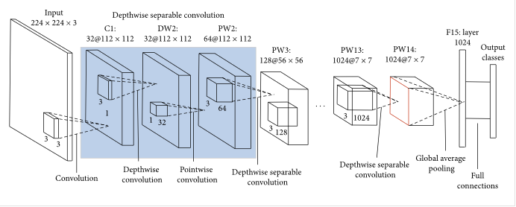

VGG16

VGG16 is a simple and widely used Convolutional Neural Network (CNN) Architecture used for ImageNet, a large visual database project used in visual object recognition software research. VGG16 is a CNN Architecture, which was used to win the ImageNet Large Scale Visual Recognition Challenge (ILSVRC) in 2014.

RESNET52

A residual network, or ResNet for short, is an artificial neural network that helps to build deeper neural network by utilizing skip connections or shortcuts to jump over some layers. You'll see how skipping helps build deeper network layers without falling into the problem of vanishing gradients

Inception V3

Inception v3 mainly focuses on burning less computational power by modifying the previous Inception architectures. If any changes are to be made to an Inception Network, care needs to be taken to make sure that the computational advantages aren’t lost. Thus, the adaptation of an Inception network for different use cases turns out to be a problem due to the uncertainty of the new network’s efficiency.

DenseNet

A DenseNet is a type of convolutional neural network that utilises dense connections between layers, through Dense Blocks, where we connect all layers (with matching feature-map sizes) directly with each other

***Architecture diagram***

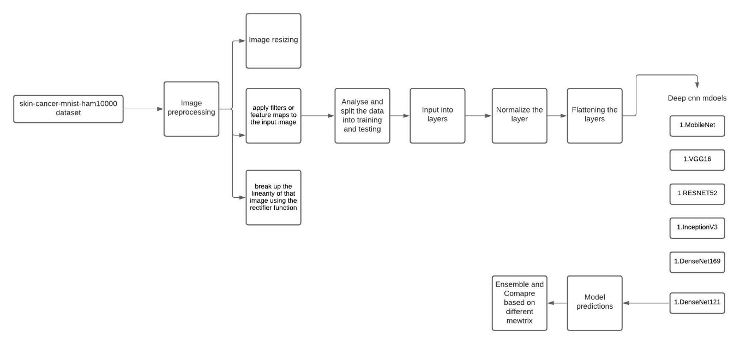

* Import Keras Packages and Libraries
* Initializing the CNN
* Adding the Convolution Layer
* Adding the Pooling layer
* Adding Flattening to the layer
* Adding the Fully Connected layer
* Compiling the CNN
* Fitting the different CNN models to image dataset

III. **Literature Survey Sample :**

In research paper [1] it is explained how Skin cancer detection done using Svm which is basically defined as the process of detecting the presence of cancerous cells in image. Skin cancer detection in this paper is implemented by using GLCM and Support Vector Machine (SVM). Gray Level Co-occurrence Matrix (GLCM) is used to extract features from an image that can be used for classification.

The authors in [2] Used vector-based SURF approach for the recognition of lesion pattern. The features found are classified using multi SVM classifier to classify the type of lesion .This system provided 86.37% accuracy, 86.53% sensitivity and 96.42% specificity rates. 611 data images were used which has 4 types of skin lesion classes. [16] proposed computerized method which is fully automatic for skin lesion classification. In this research they pre trained three models ResNet-18, AlexNet, and VGG16 as feature generators. Support Vector Machines are then trained using these extracted features. In the last stage, these classifier outputs are fused to obtain classification. They used 150 images from ISIC 2017, yielding a performance of 83.83% for melanoma and 97.55% for seborrheic keratosis classification.

[3]The author has used U-net algorithm of CNN for segmentation process. They used, Edge Histogram (EH), Local Binary Pattern (LBP), Gabor method and Histogram of Oriented Gradients (HOG), to extract the features from the segmented images. Features that are extracted from the above-mentioned methods were fed into the Support Vector Machine (SVM), and also K-Nearest Neighbour (KNN), Naïve Bayes (NB) and Random Forest (RF)classifiers, to diagnose whether it is benign or Melanoma. This experiment is carried out with 900 dermoscopic images. International Skin Imaging Collaboration (ISIC) is used for images .10% of the 900 segmented images are used as test data and the remaining 90% of the 900 images are used as training data for classification.

[4]In this proposed model the authors uses technologies such as image processing and data mining for the diagnosis of the disease of the skin. The image of skin disease is taken and it must be subjected to various pre-processing for noise eliminating and enhancement of the image. This image is immediately segmentation of images using threshold values. Finally data mining techniques are used to identify the skin disease and to suggest medical treatments or advice for users. This expert system exhibits disease identification accuracy of 85% for Eczema, 95% for Impetigo and 85% for Melanoma. A useful inference which was derived by authors in [5] was how deep Learning processing of dermoscopic images followed by sonification results in an accurate diagnostic output for SMP, implying that the quality of the dermoscope is not the major factor influencing DL diagnosis of skin cancer.

The article proposed by author in [6] talks about the analysis of more than 24,000 skin cancer images by convolutional neural network (ConvNet) model applying with three architectures (InceptionV3, ResNet, and VGG19) with many parameters to identify the best architectures in the classification of these images and getting extremely acceptable results.

Authors in [7] presented a fully automated method for segmenting the skin melanoma at its earliest stage by employing a deep-learning based approach, namely faster region-based convolutional neural networks (RCNN) along with fuzzy k-means clustering (FKM).

[8]They proposed new prediction model novel regularizer technique that classifies a given lesion into either benign or malignant. So, this is a binary classifier. The data set is taken from ISIC,5600 images are used for training CNN, and 2400 images for validation. This proposed model achieved an accuracy of 97.49% in determining benign vs malignant. The performance of CNN in terms of AUC-ROC is calculated for different cases with an embedded novel regularizer.

Tri Cong Pham , Van Dung Hoang [9] Proposed deep CNN, that solves the underfitting problem and avoids overfitting. Their proposed best model selection method with increase in Youden Index (YI) on both test-10 and MClass-D datasets also outperforms traditional methods. Moreover, their solution effectively outperformed 153 out of 157 dermatologists, which surpasses the current state-of-the-art solution by 17 dermatologists.

Khushbakht Iqtidar [10] Determined the area of interest of the lesion part, dermoscopic skin lesion images are first segmented using k-means clustering. Next, extensive feature extraction is performed on segmented images by using feature descriptors: local binary patterns (LBP), histogram of oriented gradients (HOG), and bag of visual words (BoVW). These features are evaluated on a wide range of classification methodologies. Experimental analysis revealed that BoVW features with support vector machines yield the highest results in terms of 99.8% accuracy, 100% sensitivity, and 99.5% specificity.

|  |  |  |  |
| --- | --- | --- | --- |
| Sno | Algorithm | Advantages | Disadvantages |
| 1 | Support Vector Machine and GLCM for feature extraction | Accuracy of proposed system is 95% using this algorithms. | GLCM works only on gray level image matrix to capture most common feature such as contrast, mean, energy, homogeneity |
| 2 | SVM classifier and vector-based SURF approach for the recognition of lesion pattern. | This system provided 86.37% accuracy, 86.53% sensitivity and 96.42% specificity rates. | No visible issues could be identified. |
| 3 | U-net algorithm of CNN, Support Vector Machine (SVM), K-Nearest Neighbour (KNN), Naïve Bayes (NB) and Random Forest (RF)classifiers | The accuracy produced was 85.19%,using SVM classifier. The experimental results of classification methods for the extracted features. SVM predicts Recall of (50%), accuracy of (85.19%) and F1_scoreof (46%) and Naïve Bays classification predicts Precision of (45.62%). | No visible issues could be identified. |
| 4 | AdaBoost, BayesNet, J48, MLP, NaiveBayes | The accuracy achieved was above 85% and use of Multi-Layer Perceptron (MLP) and J48 are main classifiers used in achieving this accuracy. | Only for three skin diseases are taken care of they are Eczema, Impetigo and Melanoma  Also while capturing the image the camera lens need to be adjusted. |
| 5 | A convolutional neural network architecture based on the Inception V2 network was utilized.  And K-means clustering algorithm | Results in a sound ROC AUC of 0.81. Applying a twice extra weight to sensitivity upon positive predictive value derives a 92% sensitivity and a 42% specificity | Visual inspection of the raw sound files derived from SMP does not distinguish between benign, dysplastic nevus and MM (Fig. 3 c). Consequently, a secondary machine learning was applied to the raw sound files in order to diagnose malignancy. |
| 6 | Convolutional neural network (InceptionV3, ResNet, and VGG19) and learning algorithms as Gradient descent, RMSProp, Adam | The InceptionV3 architecture has achieved a diagnostic accuracy of approximately 86.90%, precision of 87.47%, sensitivity of 86.14%, and the specificity of 87.66% | VGG19 performance with adam as learning algorithm was worst among three , with an accuracy of 73.11% |
| 7 | Convolutional neural networks (RCNN) along with fuzzy k-means clustering (FKM) | The presented method attains an average accuracy of 95.40, 93.1, and 95.6% on the ISIC-2016, ISIC-2017, and PH2 datasets | The first issue is the exact location of the multiple objects and the other issue is the category of each object. |
| 8 | Deep convolutional neural networks (CNNs) with novel regulazier | The proposed model achieved an average accuracy of 97.49%, which in turns showed its superiority over other state-of-the-art methods. The performance of the CNN in terms of AUC-ROC with an embedded novel regularizer is tested on multiple use cases | , when the dimensionality is very high and the number of instances is very low, the use of these regularizations is pointless |
| 9 | CNN architecture with binary skin cancer classification system | significant solution for the architecture designing and imbalance data issue in binary melanoma image classification. | With the limited resources and timeframe, only conducted our experiment on one customized fully connected layer of two hidden layers |
| 10 | k-means clustering for the extraction of the region of interest in the image. Feature extraction performed over a range of feature descriptors namely LBP, HOG, and BoVW | BoVW features with support vector machines classifier yield the highest results in terms of 99.8% accuracy, 100% sensitivity, and 99.5% specificity. | Complex classification tasks are effectively handled by SVM eats a lot of time |

## IV. PROPOSED ALGORITHM

1. We start with an input image. In our case, we would use a single image from our dataset of 1000 images and later we would loop the function over the other images.

2. We apply filters or feature maps to the input image, which gives us a convolutional layer.

3. We then break up the linearity of that image using the rectifier function.

4. The image becomes ready for pooling, the purpose of which is to provide our CNN with “spatial invariance”. After pooling, we end up with a pooled feature map.

5. We then flatten our pooled feature map before inserting into an artificial neural network.

Throughout this entire process, the network’s building blocks, like the weights and the feature maps, are trained and repeatedly altered in order for the network to reach the optimal performance that will make it able to classify images and objects as accurately as possible.

Building the Pipeline

1. Initializing the CNN

Preparing the base models:

* 1. MobileNet
  2. VGG16
  3. RESNET52
  4. InceptionV3
  5. DenseNet169
  6. DenseNet121

1. Preprocessing the image using ImageDataGenerator from keras api
2. Defining a function for flow from dataframe
3. Building the CNN Model
4. Create base for pretrained models
5. Input into the layers
6. Applying batch normalization on the layers
7. Using Gaussian Noise class to mitigate the overfitting
8. Flatenning the layers
9. Adding pooling layer
10. Compiling the model

**V. EXPERIMENTS RESULTS**

Dateset after preprocessing

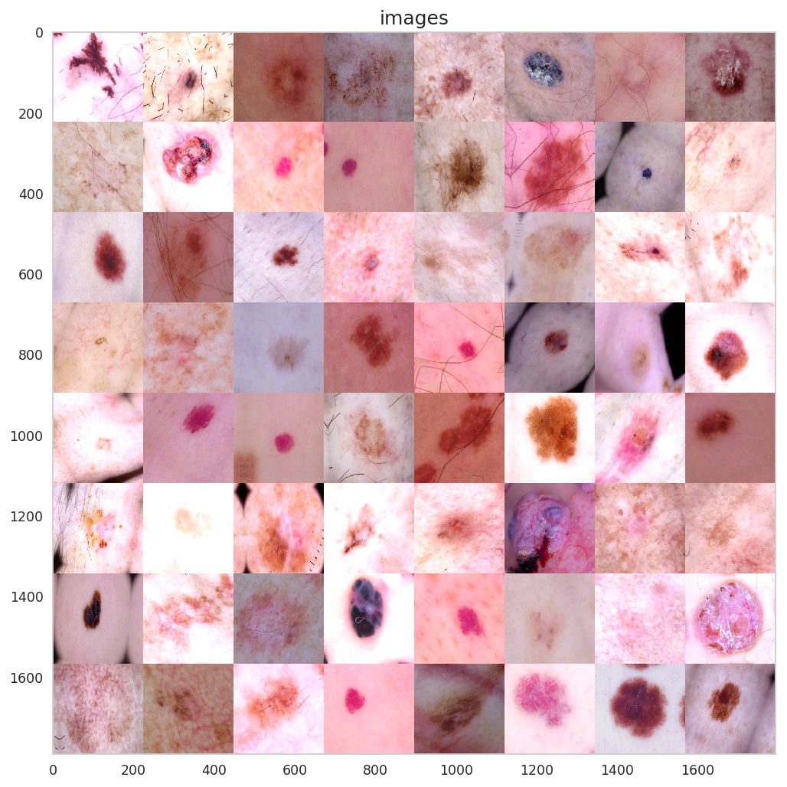

Imbalance in classes

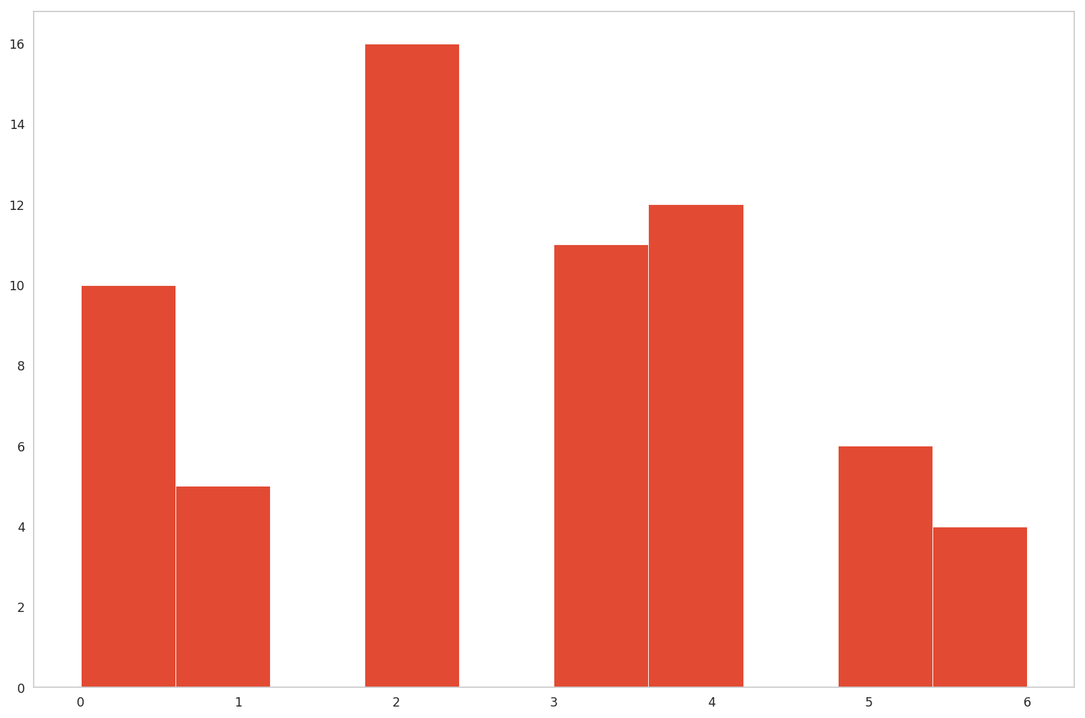

Binary loss and accuracy

MobileNet

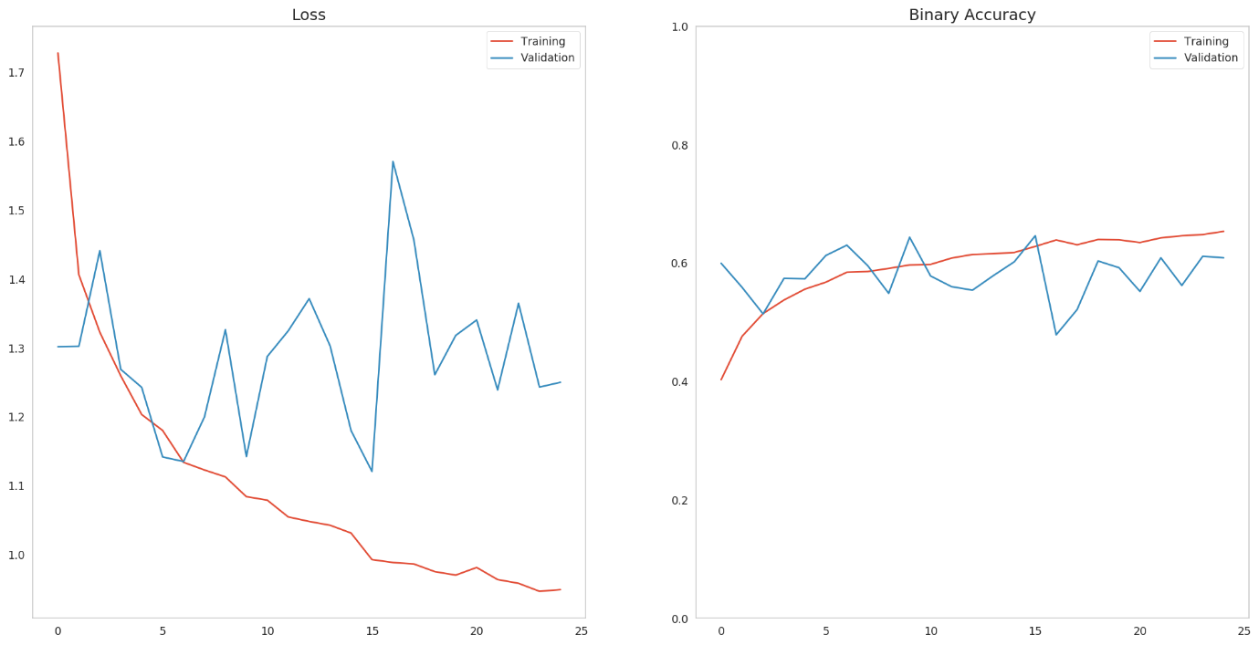

Resnet

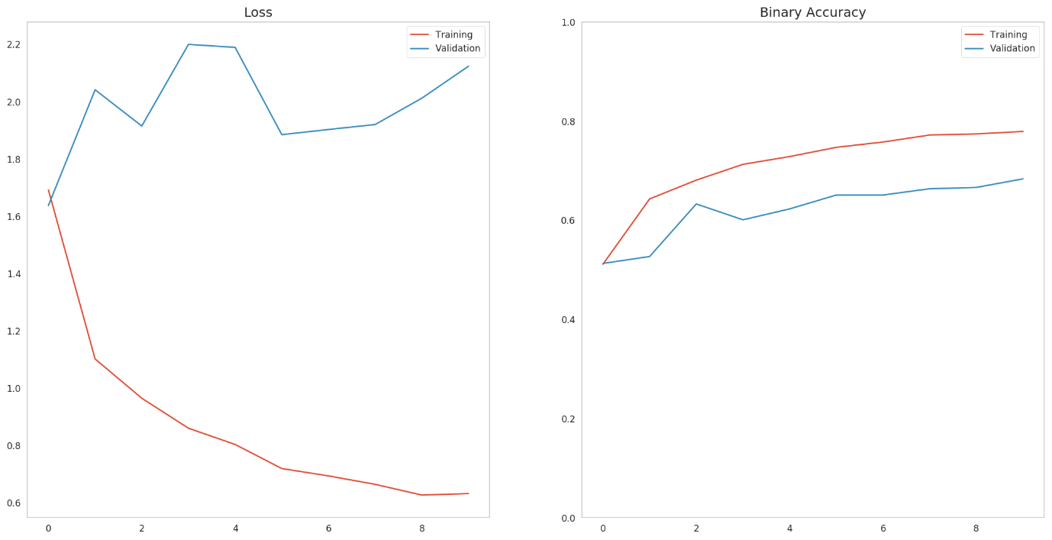

InceptionV3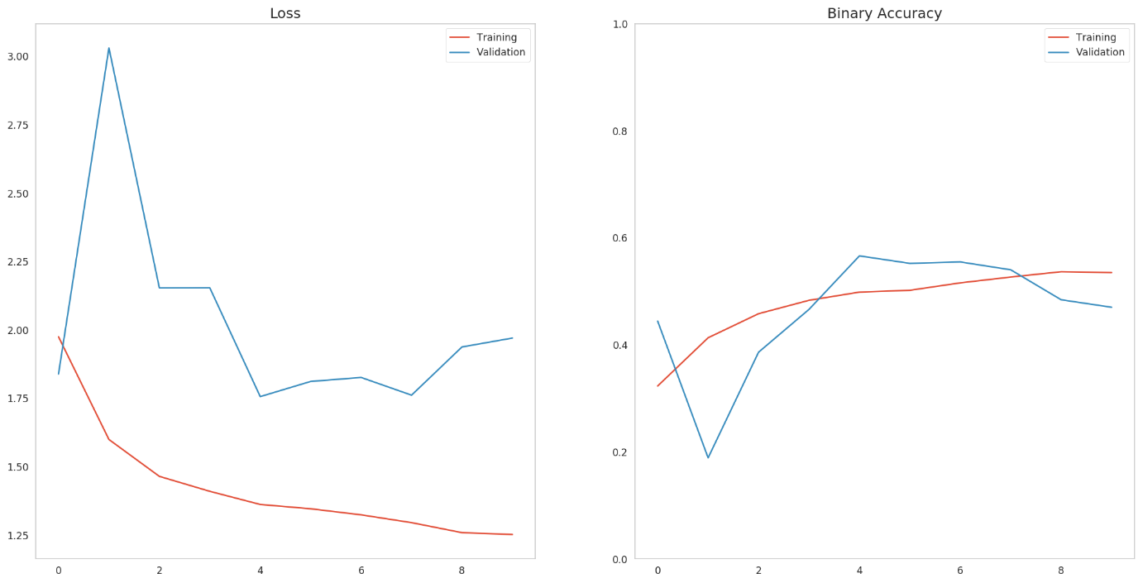

Detailed performance by group

Mobilenet

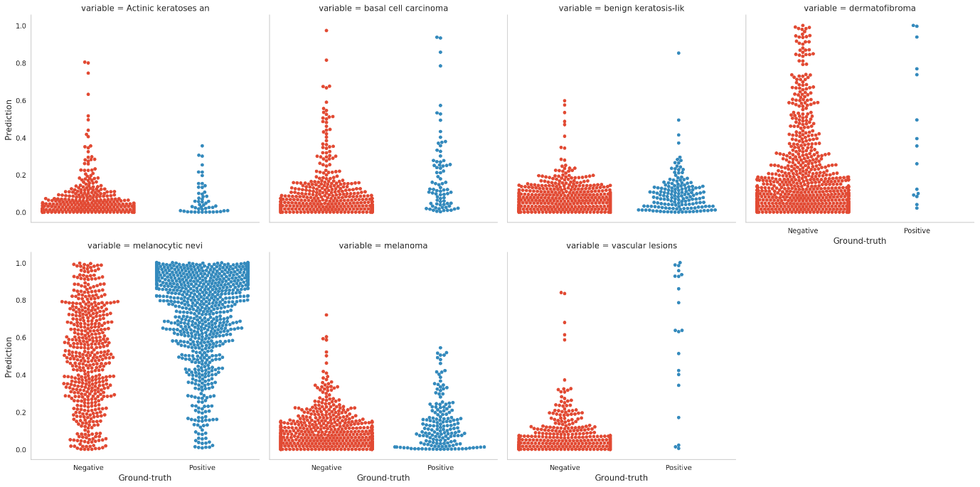

Resnet

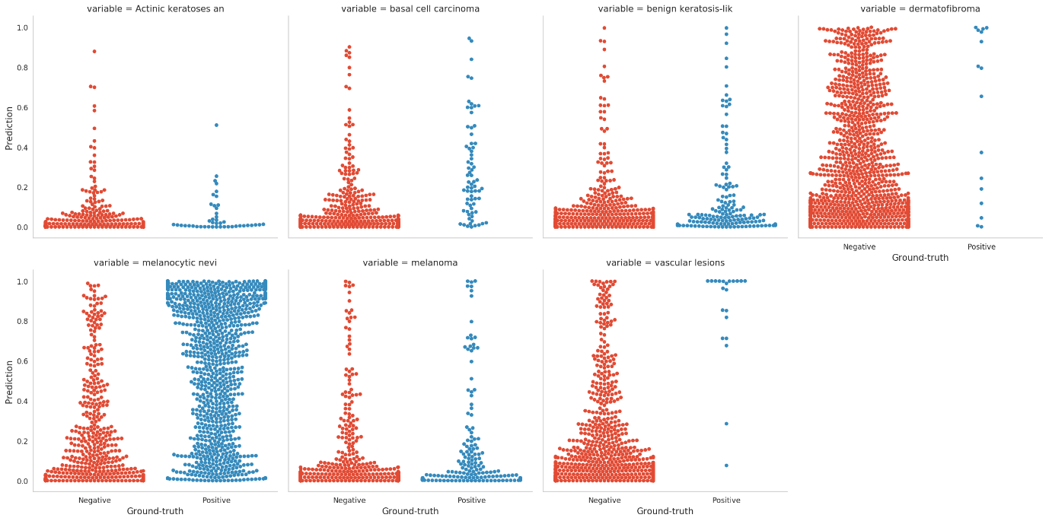

InceptionV3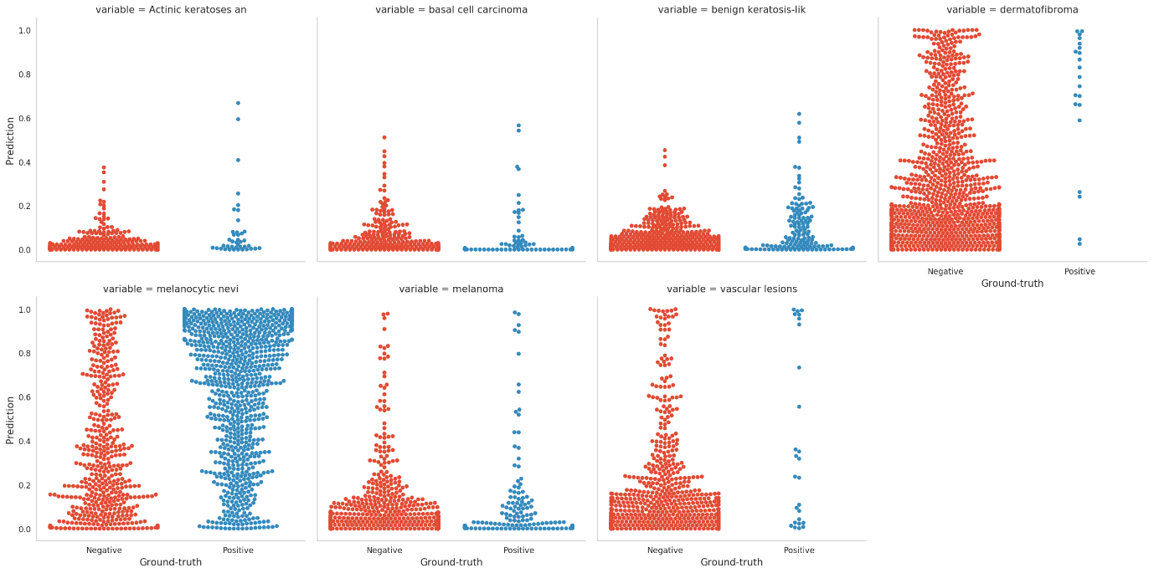

Class-level ROC curves

Mobilenet

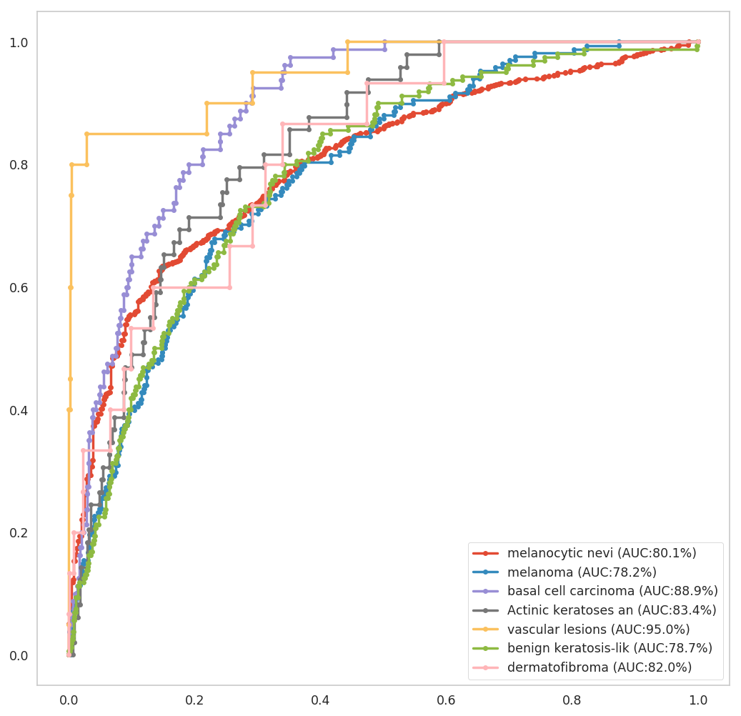

Resnet

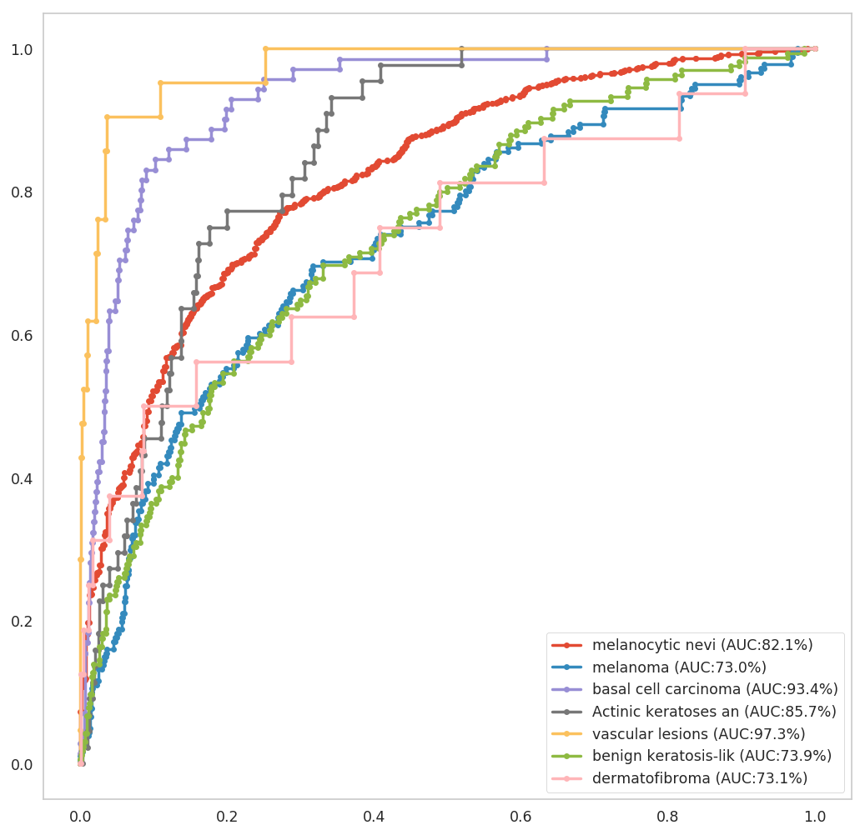

InceptionV3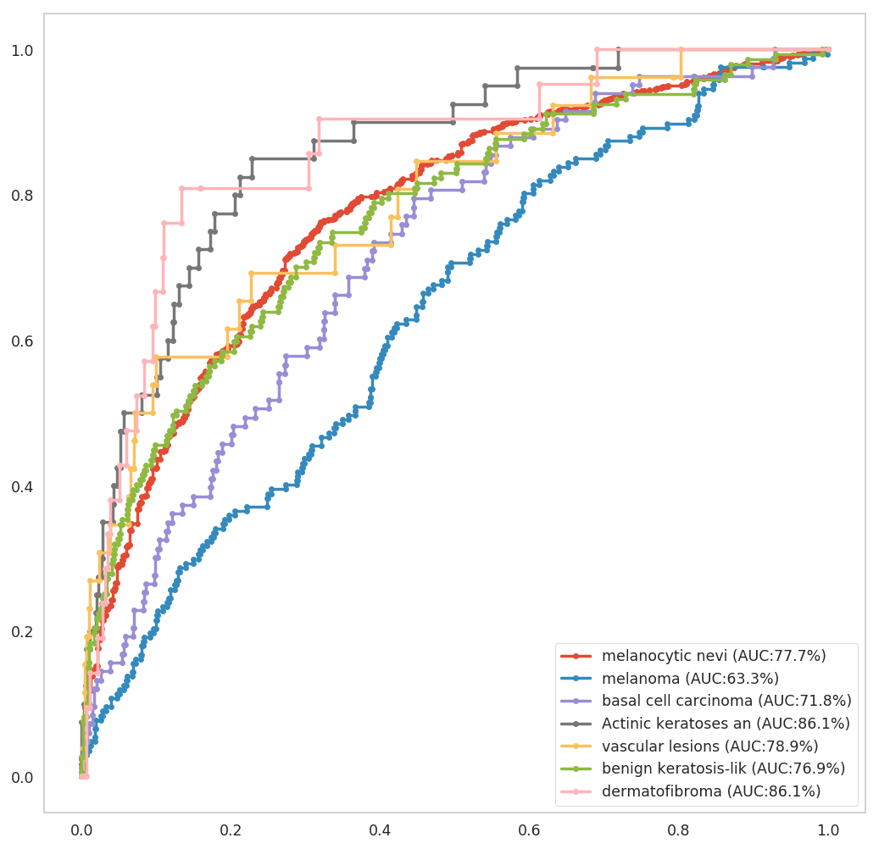

Results

|  |  |  |  |
| --- | --- | --- | --- |
| Metric | MobileNet | Resnet | InceptionV3 |
| Binary Loss | 1.12 | 1.62 | 1.75 |
| Accuracy | 64.6 | 51.3 | 56.6 |
| AOC | 83 | 82.6 | 77.2 |

## REFERENCES

1]Ansari, Uzma and Tanuja K. Sarode. “Skin Cancer Detection Using Image Processing.” (2017).

[2]Thompson F, Jeyakumar MK. Vector based classification of dermoscopic images using SURF. IJAER. 2017;12:1758–64.

[3]Seeja R.D., Suresh A. Deep Learning Based Skin Lesion Segmentation and Classification of Melanoma Using Support Vector Machine (SVM) Asian Pac. J. Cancer Prev. 2019;20:1555–1561. doi: 10.31557/APJCP.2019.20.5.1555

[4]Amarathunga, A., Ellawala, E.P., Abeysekara, G., & Amalraj, C.R. (2015). Expert System For Diagnosis Of Skin Diseases. International Journal of Scientific & Technology Research, 4, 174-178.

[5] Dascalu, A., & David, E. O. (2019). Skin cancer detection by deep learning and sound analysis algorithms: A prospective clinical study of an elementary dermoscope. EBioMedicine. doi:10.1016/j.ebiom.2019.04.055

[6]Mijwil, Maad. (2021). Skin cancer disease images classification using deep learning solutions. Multimedia Tools and Applications. 80. 10.1007/s11042-021-10952-7.

[7]Nawaz, M., Mehmood, Z., Nazir, T., Naqvi, R. A., Rehman, A., Iqbal, M., & Saba, T. (2021). Skin cancer detection from dermoscopic images using deep learning and fuzzy k ‐means clustering. Microscopy Research and Technique. doi:10.1002/jemt.23908

[8] Albahar, M. A. (2019). Skin Lesion Classification using Convolution Neural Network with Novel Regularizer. IEEE Access, 1–1. doi:10.1109/access.2019.2906241

[9] Pham, T. C., Tran, C. T., Luu, M. S. K., Mai, D. A., Doucet, A., & Luong, C. M. (2020, October). Improving binary skin cancer classification based on best model selection method combined with optimizing full connected layers of Deep CNN. In 2020 International Conference on Multimedia Analysis and Pattern Recognition (MAPR) (pp. 1-6). IEEE.

[10] Iqtidar, K., Iqtidar, A., Ali, W., Aziz, S., & Khan, M. U. (2020, November). Image Pattern Analysis towards Classification of Skin Cancer through Dermoscopic Images. In 2020 First International Conference of Smart Systems and Emerging Technologies (SMARTTECH) (pp. 208-213). IEEE.